# INFSCI 2710 – Database Management – Spring 2018

## Homework#1 – A Simple Web Application

**This assignment is worth 100 points**

Type your answers below each question. Make sure to provide detailed answers/screenshots. Submit your responses in a Microsoft Word Document or PDF format.

You will need to use the client/server environment and the database schema from Lab session to finish this assignment. Make sure you complete all the practices on the slides.

**\*Task 1 (20 points):** Create a PHP script - selectStudent.php - in your web server. The script is designed to display all the record of ‘***student***’ table, total number of students and the average grade. That is, when you link to <http://localhost/selectStudent.php> in your browser, you will see the similar result of Figure 1.

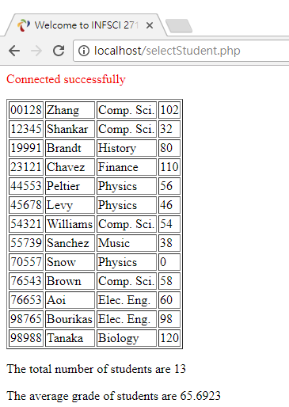

Figure 1: selectStudent.php (Task 1)

**\*Task 2 (20 points)**: Create 1) a PHP script ‘addStudent.php’; 2) an HTML file ‘addStudent.html’ (shown in Figure 2) - in your web server. The scripts are designed to insert a new record to ‘student’ table. That is, when you link to http://localhost/addStudent.html in your browser, you will see the similar result as below. **The department field should be designed as a dropdown list to fulfill the requirement of the foreign key.**

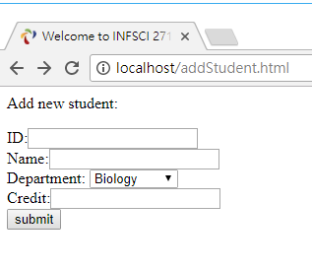

Figure 2: addStudent.html (Task2)

After you input all the fields and click submit. The new student profile will be inserted into the database. And you should let the user know if the work is done (with a link back to selectStudent.php) or unsuccessful (with a link back to addStudent.html) as shown in Figure 3.

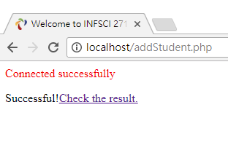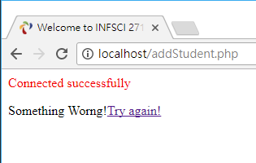

Figure 3: addStudent.php (Task 2)

**\*Task 3 (20 points):** 1) Create a PHP script ‘deleteStudent.php’; 2) Modify the script of ‘selectStudent.php’ with a new ‘Delete’ link in each row (shown in Figure 4) and a “Add New Student” link (point to addStudent.html) on the top. That is, when you click the link, the data row will be deleted.

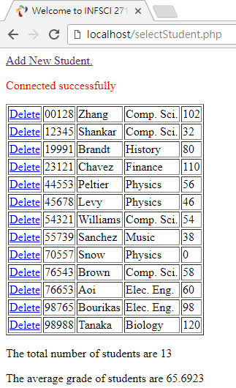

Figure 4: selectStudent.php (Task 3)

After you click the Delete link. The student profile will be deleted from the database. And you should let the user know if the work done (with a link back to selectStudent.php) or unsuccessful (with a link back to selectStudent.php) as shown in Figure 5.

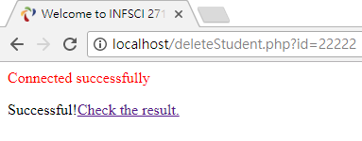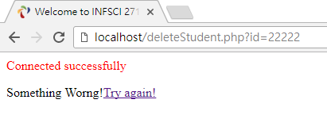

Figure 5: deleteStudent.php (Task 3)

**\*Task 4 (35 points):** 1) Create a PHP script ‘updateStudent.php’; 2) Create a PHP script ‘editStudent.php’; 3) update your PHP script ‘selectStudent.php’ with a new ‘Edit’ link in each row of data (shown in Figure 6).

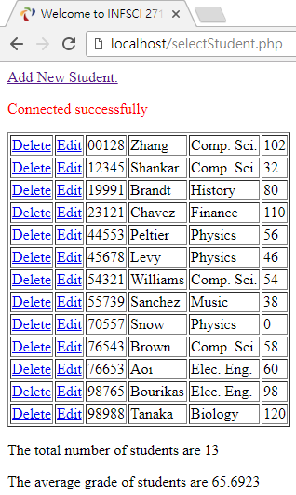

Figure 6: selectStudent.php (Task 4)

You will be directed to a new page that you can update the student data when you click the Edit link (shown in Figure 7). (The ID is not editable.)

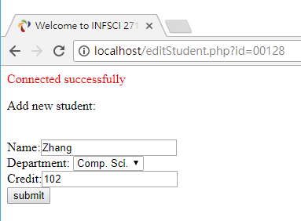

Figure 7: editStudent.php (Task 4)

After you input all the fields and click submit. The new student profile will be updated to the database. And you should let the user know if the work done (with a link back to selectStudent.php) or unsuccessful (with a link back to selectStudent.php) as shown in Figure 8.

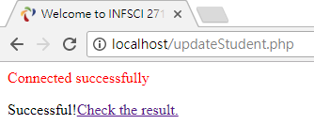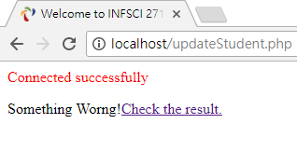

Figure 8: updateStudent.php (Task 4)

**\*Task 5 (5 Points):** Please try to add two student profiles using the function of Task 2.

• Student#1 {name=Peter O’Donovan, department=Finance, grade=90}

• Student#2 {name=Peter Lee, department=Music, grade=Ten}.

**Question 1:** Is there any issue while you are adding the two profiles?

**Question 2:** How can you solve the issues you observed? Please discuss or show your solution (code) below.

**A runnable code is preferred, but you will get credit by explaining your observation and prospect solutions.**

**To submit your homework assignment:**

1. Save all your code/script in one folder.
2. Make sure you take the screenshot (**full screen, with date/time information**) of each task (follow the steps as the question presented.)
3. Insert resulting image (screenshots of each task) into your Word Document (or PDF) as the answer to each question. Add some text/explanation to enhance the readability of your answer, e.g., add a short caption to each screenshot.
4. Name the Word document (PDF) with your answers as ***YourPittID_infsci2710_homework1.docx (pdf)***. In other words, if your Pitt ID (first part of your Pitt email) is abc123, your submission file should be named ***abc123_infsci2710_homework1.docx (pdf)***
5. Zip your code folder as ***YourPittID_infsci2710_homework1.zip***
6. Submit both the Zip file and document via CourseWeb

**Note:**

1. The code/script is expected to be **runnable**. You will lose 20 points if your code is not runnable. I will use the following credential to test your code.

$servername = "localhost"; $username = "root";

$password = "mysql”; $database = "lab";

1. Collaboration on homework is permitted to an extent. Specifically, students are allowed to discuss the possible solutions to a problem and help each other with logic errors. However, handing your work to someone so that they may see a copy of your solution, or dictating code to a person on line-by-line basis is not within the spirit of the collaboration policy or the honor code of the university.
2. **I expect to see you demonstrate your works/solutions step by step**.